|  |
| --- |
|  |
| NU: Project 1 Summary |
|  |
|  |
| **Shira Orlowek, Stephen Murphy, Maggie Brink & Daniel Parmet** |
| **1/12/2019** |

|  |
| --- |
| TO FLY OR NOT TO FLY: Using Data to make educated travel decisions. |

**Contents**

Project Description: 1

Question 1: Which day of the week is the cheapest to travel? 1

Question 2: Of the six most popular routes from ORD, which route has the cheapest flights on average? 2

Question 3: Of the API’s included Airlines, which has the cheapest flight options? 3

Summary: 3

# Project Description:

We used Kiwi’s Tequila API as a proxy for buying options. For scope, we looked at the period of the next six months using the API call as a one-time snap shot. Our group generated 1,086 API calls to produce a data set with 15,843 data points. The API was set to gather data on the top six routes out of ORD: LAX, JFK, EWR, LGA, ATL, & SFO. Originally we set out to examine Delta Airlines, United Airlines and American Airlines. However, our API call did not pull American Airlines data and we were unable to ascertain the reason behind this. Instead, we expanded our scope to include the five airlines we could successfully pull data for: United Airlines, Delta Airlines, Spirit Airlines, Alaskan Airlines and Jet Blue. As ORD serves as a United hub we anticipated some skewed results in our data, this bias proved true and can be observed could in the data below:

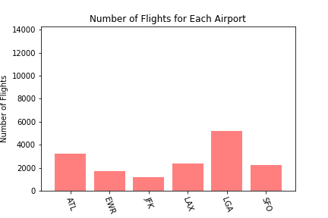 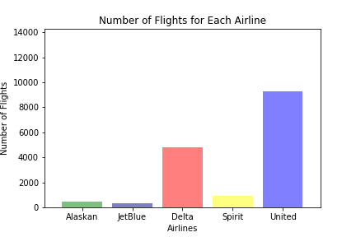

# Question 1: Which day of the week is the cheapest to travel?

Our hypothesis was that the least expensive options would be to fly on a Tuesday or Wednesday. The analysis indicated that depending on the route Tuesday or Wednesdays had the least expensive flight options. Within the data the most conclusive pricing information is shown in the flights from ORD to EWR as this was limited by the fact that only United flew to that destination. Our data shows that, on average, it is cheapest to fly on a Tuesday but the least expensive flight without bags for each route was most often found on a Wednesday. 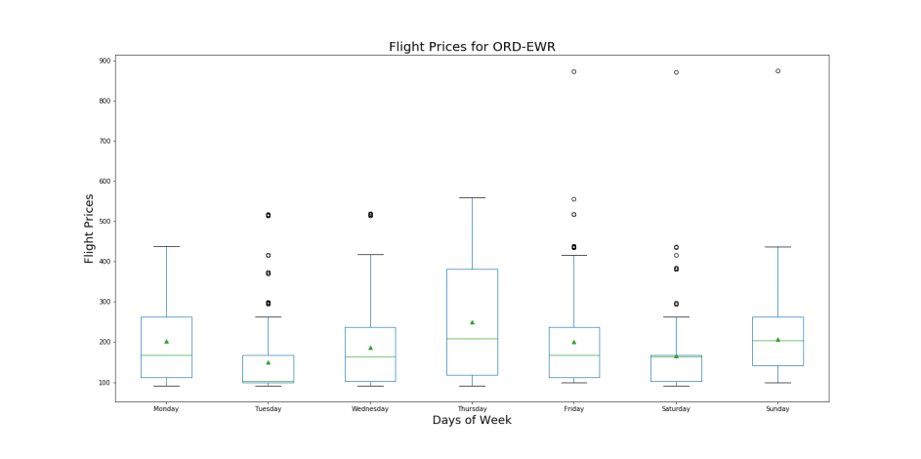

One interesting result of our research was that we uncovered what is likely an error fare by United:

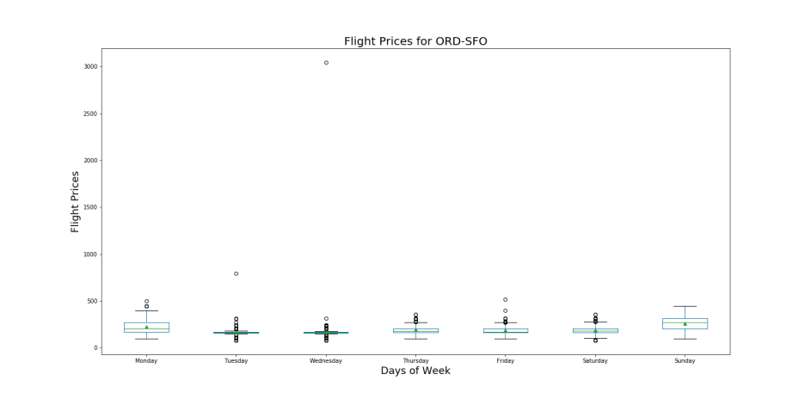

There is a single flight for $3,083 on Wednesday (generally the cheapest day) from ORD to SFO. Generally speaking, there is an entire industry built off of customers looking for errors in the other direction.

# Question 2: Of the six most popular routes from ORD, which route has the cheapest flights on average?

From the analysis, LGA on Tuesday was found to be the cheapest route option available on average.

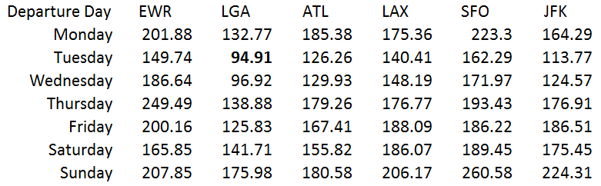

# Question 3: Of the API’s included Airlines, which has the cheapest flight options?

To answer this question we looked at the cost to fly both with a first bag, baggage fee and without baggage fees. When looking at just ticket prices, Spirit has the cheapest fares on average. However, when you include baggage fees Alaskan Airline has the cheapest overall average travel cost. With a bag, the cheapest overall flight in our data set was a United Flight and without bags was from Spirit slightly edges out United ($49 versus $51).

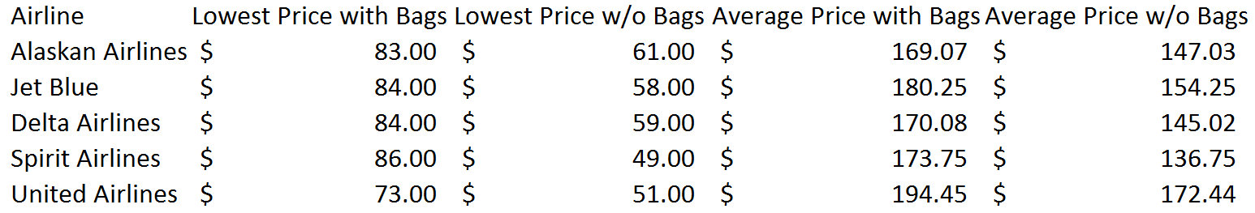

# Summary:

All this data is so to say that the airline industry is indeed a complex behemoth with revenue management pricing and very different customer segments, the answers to these questions can vary wildly from the time frame one is looking to travel.